Symbiosis Institute of Technology, Nagpur

Sub: GenAI Sem: VII

Pr. No: 21070521075 CA – II (Assignment)

Name: Shreya Anil Hajare

*Q:4* **Generate a model to represent interest calculations of a Bank account where the process ofcalculating interest for 6 months is a. Find minimum balance for each month b. Make a total ofall minimum balances c. Calculate interest based on interest rate d. Divide interest by 12 tofind one-month interest e. Multiply interest by 6 to show interest in the account. Generate amodel to represent transactions and interest calculations for 6 months.**

*Ans*: Explanation**:**

* Minimum Balance: The minimum balance during the 6-month period.
* Total Minimum Balances: The sum of the monthly balances.
* Total Interest: The interest calculated over 6 months based on the total of the monthly balances and the annual interest rate.

This code provides a clear and concise implementation of your requirements. You can adjust the initial balance and interest rate to see different outputs.

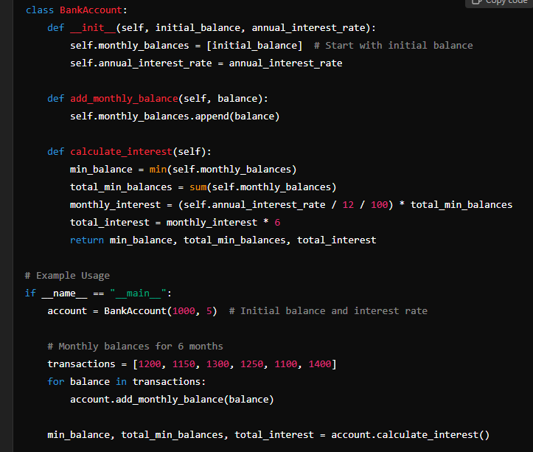

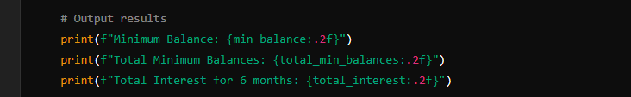

OUTPUT:

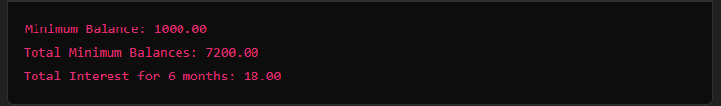

*Q:5* **Generate a model for Covid 19 with symptoms of parameters like fever, cold, shivering,weight loss, generate 100 model data with random values for each parameter and order byparameter lowest to highest in display based on the input parameter.**

### *Ans*: Explanation

* Data Generation: The generate_covid_data function creates random values for symptoms of COVID-19 (fever, cold severity, shivering severity, and weight loss).
* Sorting: The sort_data function sorts the DataFrame based on the specified parameter.
* Output: The code prints the top 10 entries of the sorted data based on the chosen symptom parameter.

You can change the parameter_to_sort variable to 'Cold', 'Shivering', or 'Weight Loss' to sort based on those parameters instead.

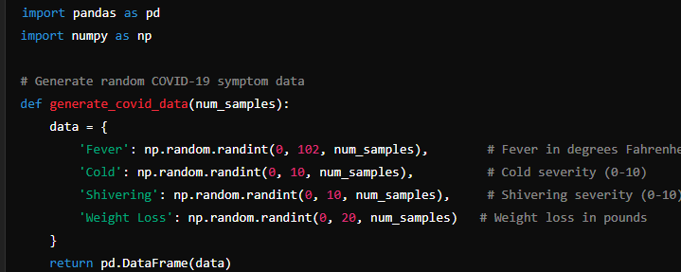

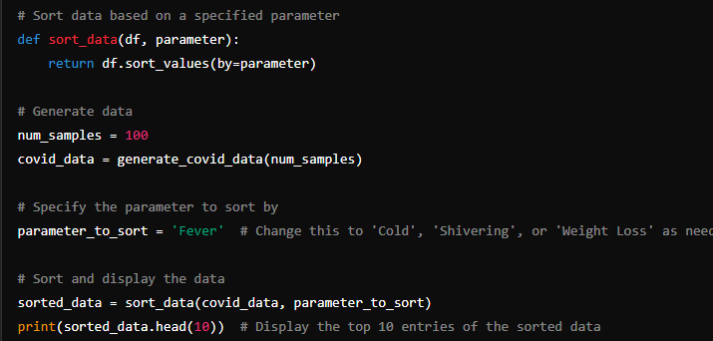

OUTPUT:

